**BRAC UNIVERSITY**

**Department of Computer Science & Engineering**

**Practice Problem sheet (Week7)**

**CSE 350: Digital Electronics and Pulse Technique** 

# **Question 1**

## 

For the ECL logic circuit above, ignore the base currents and assume Reference voltage, VR to be the average of logic high and logic low values. Also, assume when Q1 and Q2 are conducting, the B–C voltages of Q1 and Q2 are **-0.1V**.

| (a) | **Determine** the logical low and high voltages for the circuit. Also, calculate the possible value of reference voltage, VR. |
| --- | --- |
| (b) | **Determine** RC1 and RC2. |
| (c) | **Calculate** the power dissipated in the circuit for the following cases: (i) vx = vy = logic 1, and  (ii) vx = vy = logic 0. |

Solution:

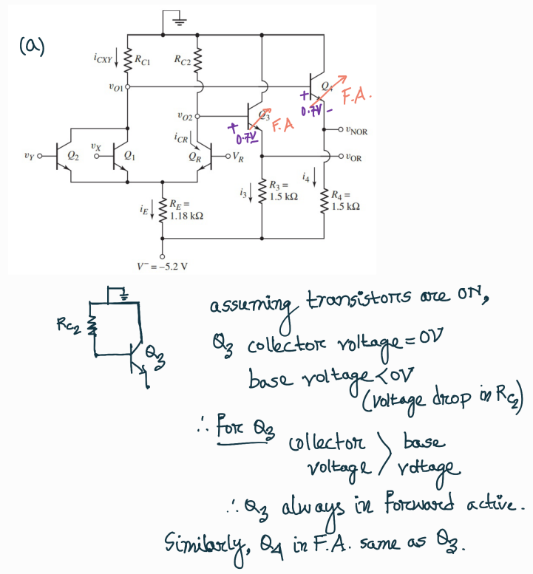

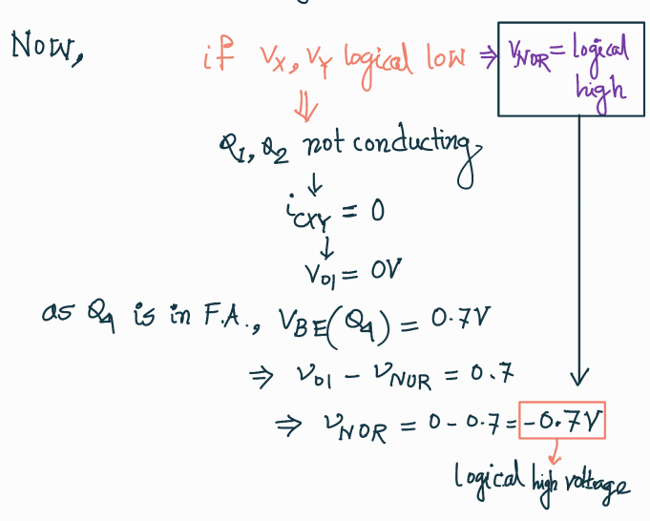

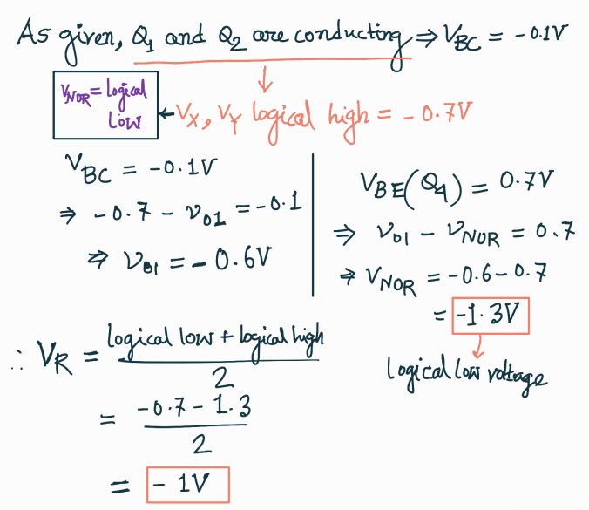

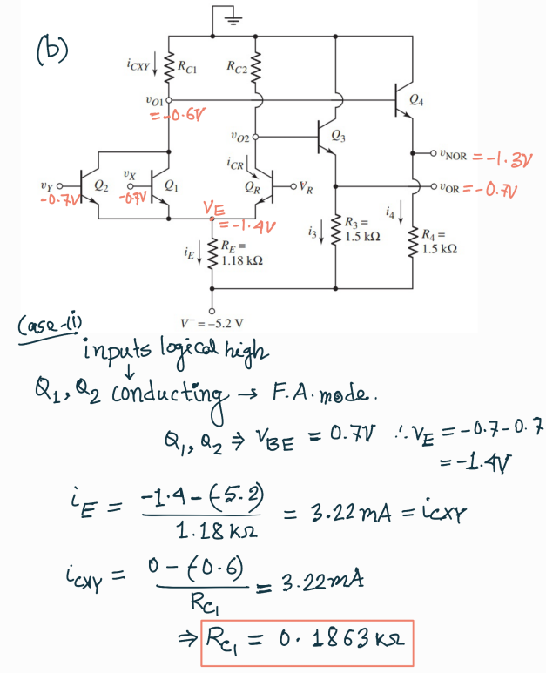

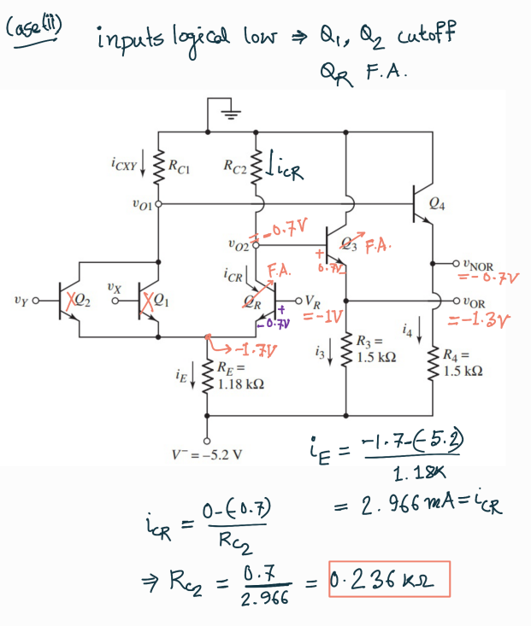

There is a mistake in the VO2 calculation above. For Q3, VBE = VO2 – VOR = 0.7V

So, VO2 = 0.7 + (-1.3) = -0.6V

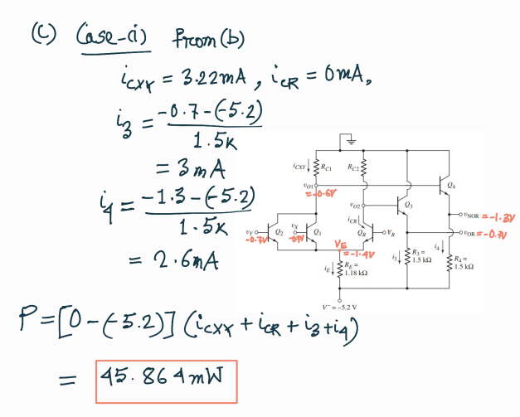

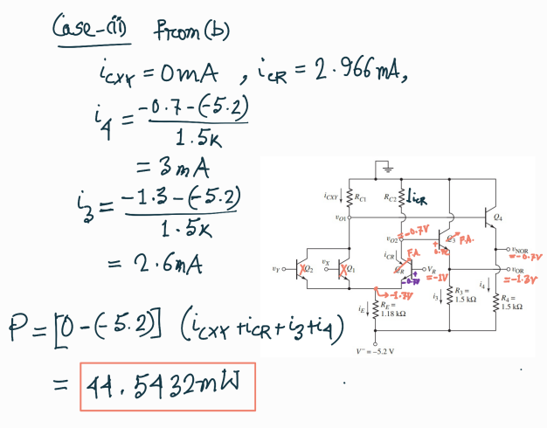

# **Question 2**

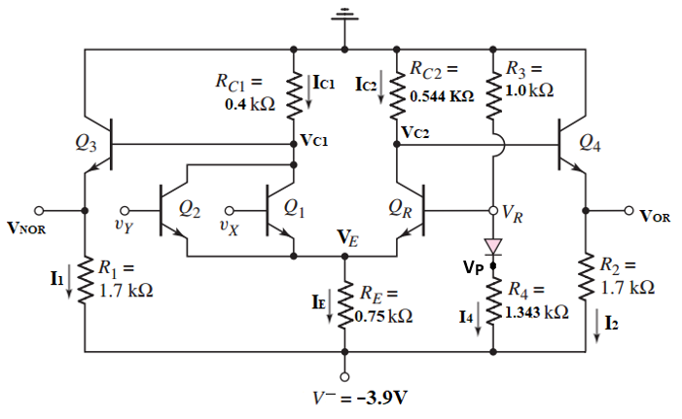

For the ECL OR/NOR circuit above, ignore the base currents and assume Reference voltage, **VR** to be the **average** of logic high and logic low values.

| (a) | **Determine** the logic 0 and logic 1 voltage values for outputs VOR and VNOR. |
| --- | --- |
| (b) | When inputs VY and Vx are at Logical High, **calculate VP**, **I1**, **I2** and **I4**. |
| (c) | **Calculate** the power dissipated in the circuit for the case mentioned in (b). |

Solution:

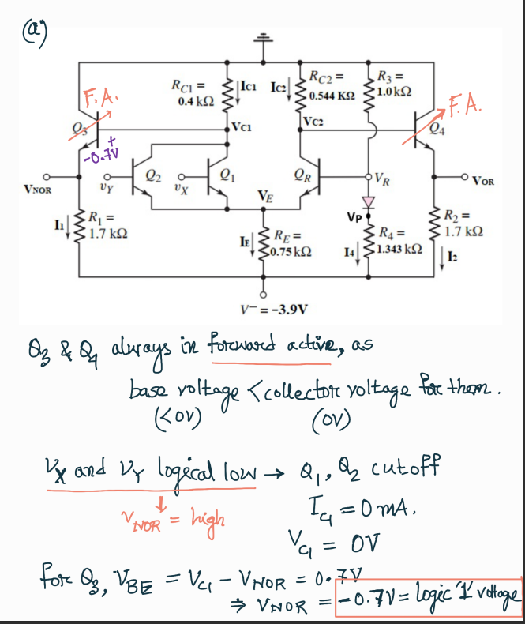

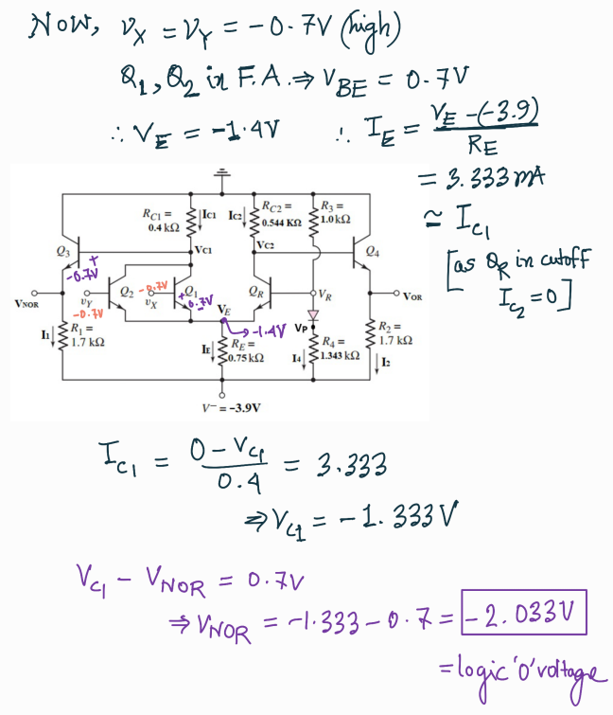

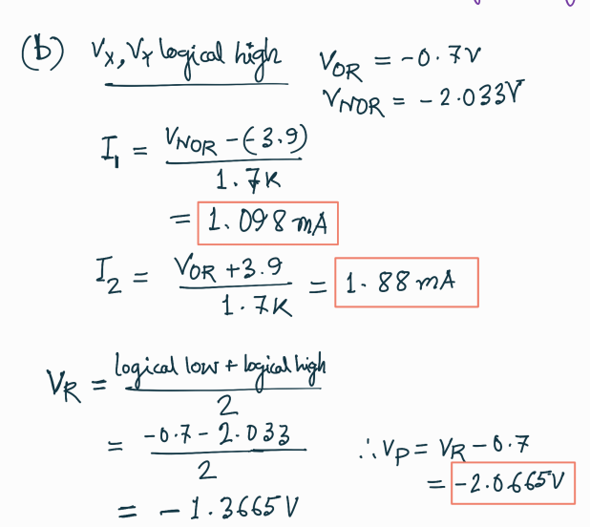

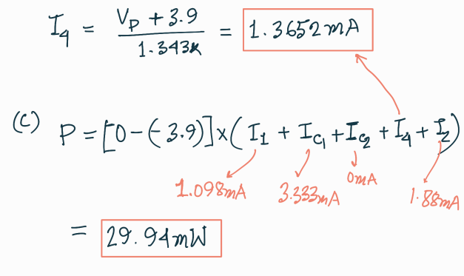

# **Question 3**

# 

Consider the ECL circuit in the above figure. Ignore the base currents.

| (a) | Determine RC2 such that v2 = −1 V when Q2 is on and Q1 is off. |
| --- | --- |
| (b) | For vin = −0.7, determine RC1 such that v1 = −1 V. |
| (c) | Find vO1 and vO2 for (i) vin = −0.7 V and (ii) vin = −1.7 V. |
| (d) | Find the power dissipated in the circuit for both the cases mentioned in (c). |

Solution:

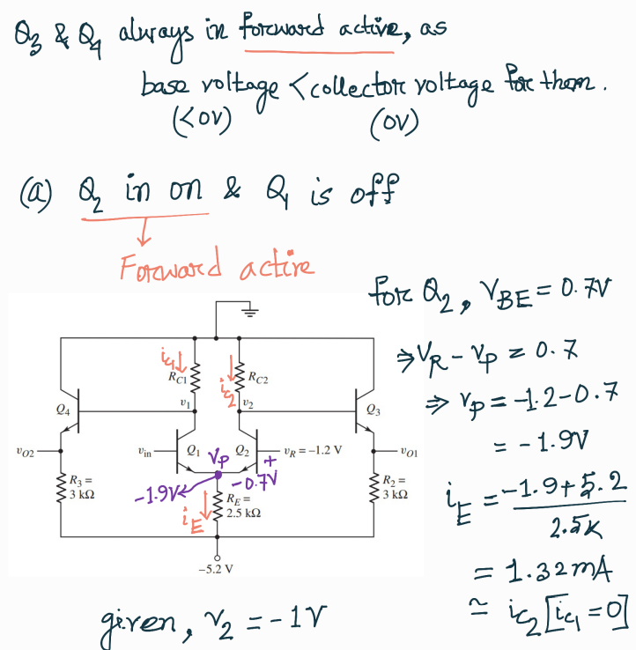

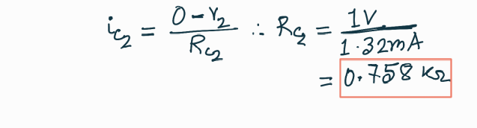

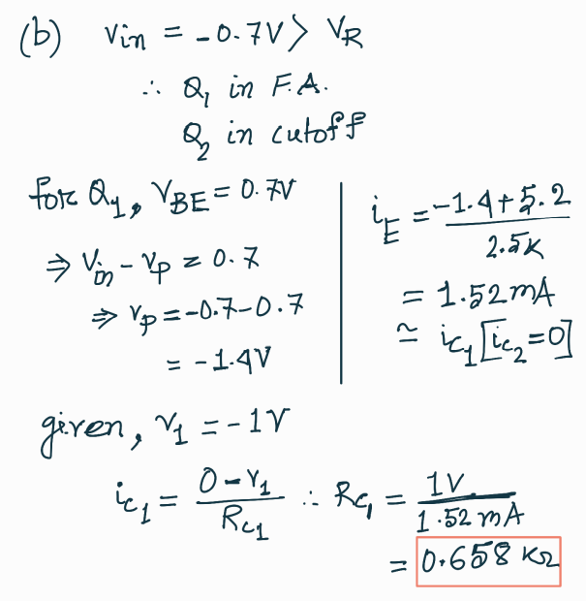

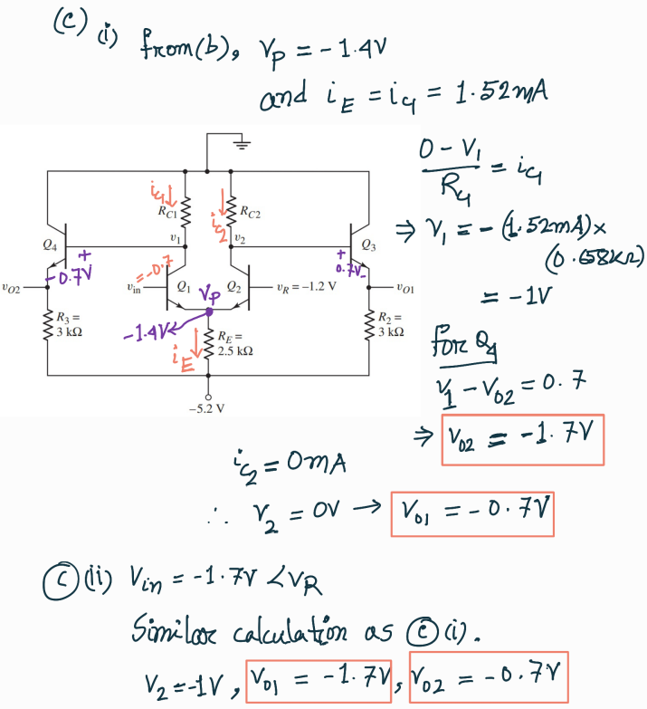

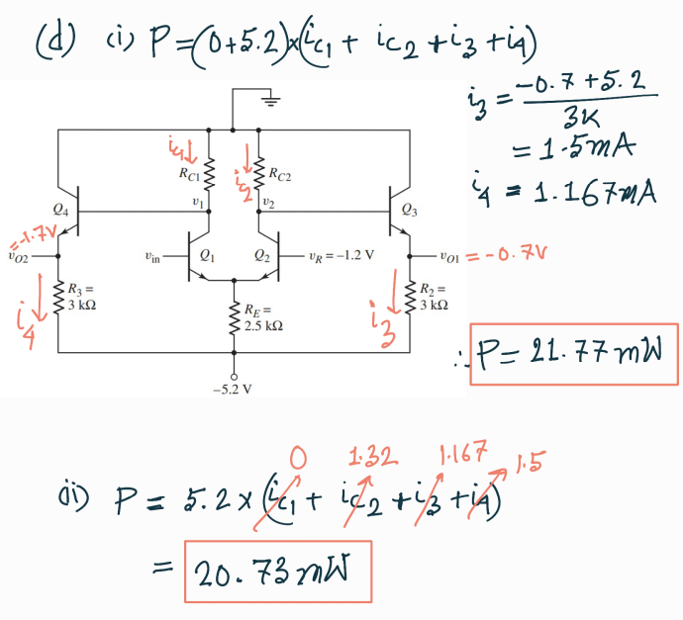

# **Question 4**

# 

Consider the ECL circuit in the figure above, the logical high and low values are -0.7V and -1.4V respectively. Assume that the reference voltage VR is the average of the logical high and low values. Assuming transistor base currents are negligible, design the reference voltage generation circuit so that the currents through R5 and R2 are the same, and the reference voltage circuit power consumption is limited to 1mW. (Find the values of R1, R2 and R5)

Solution:

